Create Database Table spaces and Tables
- Create a TEMP directory.
- Run the InstallShield Wizard and Extract the Database DDL to the TEMP directory.
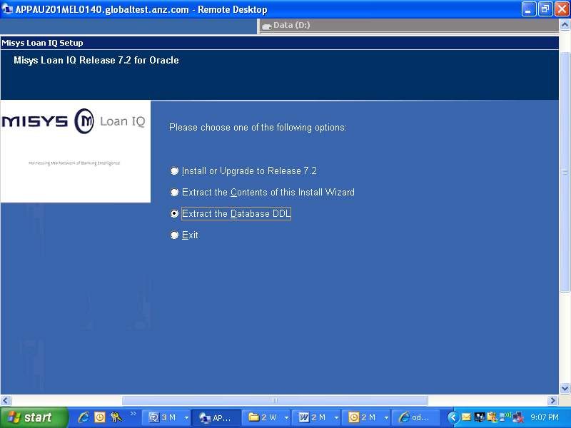
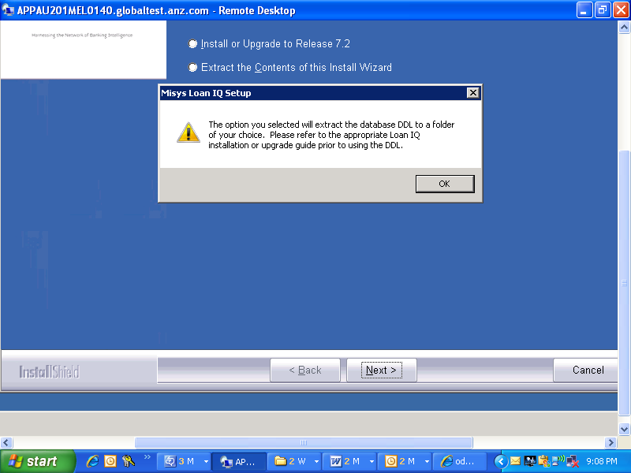
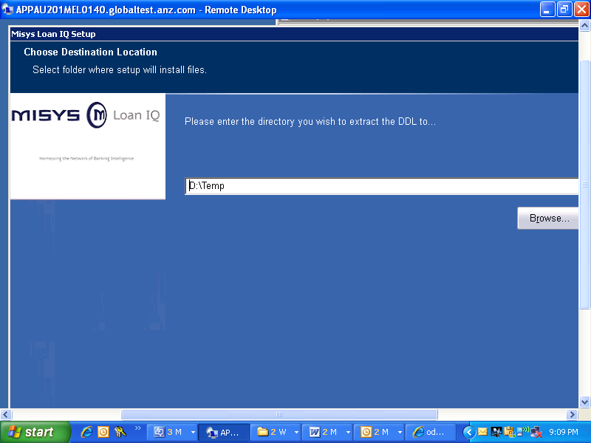
- Extract the Mstr72_opt_idx_<database>.ddl from the zip file to the TEMP directory.
Notes:
- A message is displayed when the extract is completed, and you are returned to the Wizard. You do not need to exit the Wizard while completing the Database Installation.
- All of the following steps should be executed within the TEMP directory.
- When preparing the installation scripts, the variables for [COLLECTION], [SERVID], and [SCHEMA] are case sensitive and must match the values required for your database. To properly replace the indicated variables and associated brackets, a global replace should be performed as shown in the example below:
Find what: [SCHEMA]
Replace with: your table owner
For an Oracle database, continue with the Install Oracle Database Scripts section below.
For a DB2 database, continue with the Error: Reference source not found section on page Error: Reference source not found.
For an MSS database, continue with the Error: Reference source not found section on page Error: Reference source not found.

Install Oracle Database Scripts

Edit Oracle Database Scripts
Warning: Make sure to complete all of the following edits before continuing with the Execute Oracle Database Scripts section on page 3.
- Edit createusers.sql.
Replace all instances of [SCHEMA] with the schema of your Oracle tables (for example, LS2USER).
- Edit createdb.ddl.
Replace all instances of [TSPATH] with the path for your tablespaces.
Replace all instances of [IXPATH] with the path for your indexes.
Replace all instances of [LOBPATH] with your Oracle database large object path.
Replace all instances of [SCHEMA] with the schema of your Oracle tables (for example, LS2USER).
Note: Please be sure to include a trailing back-slash in the above paths (for example, C:\TSPATH\).
- Edit ENHANCEMENTS.DDL.
Replace all instances of [SCHEMA] with the schema of your Oracle tables.
- Edit Triggers_ORA.ddl.
Replace all instances of [SCHEMA] with the schema of your Oracle tables.
- Edit Functions_ORA.ddl.
Replace all instances of [SCHEMA] with the schema of your Oracle tables.
- Edit Mstr72_opt_idx_ora.ddl.
Replace all instances of [SCHEMA] with the schema of your Oracle tables.
- Edit convsql.sql.
Replace all instances of [SCHEMA] with the schema of your Oracle tables (for example, LS2USER).
- Edit dbms_stats.sql – or – genanalyze.sql.
Replace all instances of [SCHEMA] with the schema of your Oracle tables (for example, LS2USER).
Note: The dbms_stats package was introduced in Oracle 8i and is Oracle’s preferred method of gathering object statistics. The analyze command is available for all versions of Oracle, however faster and better statistics can be obtained using the procedures in DBMS_STATS.GATHER_SCHEMA_STATS.
- Edit gengrants.sql.
Replace all instances of [SCHEMA] with the schema of your Oracle tables (for example, LS2USER).

Execute Oracle Database Scripts
The Error: Reference source not found table on page Error: Reference source not found summarizes the database privileges required to execute the following installation scripts.
Note: All of the steps in these instructions must be executed from a SQLPLUS Command Line on the Database Server, unless otherwise specified.
- Initialize a SQLPLUS command line.
From the command line, connect as the System Administrator of your Oracle database.
C:\> sqlplus <system administrator id>/<password>@<dbname>
An SQL prompt is displayed.
- Important! It is highly recommended that spooling be enabled during the following script executions to generate output files for review purposes and to log potential errors.
The recommended syntax is as follows:
SQL> spool <path> <scriptname>.out;
SQL> @<path>\<scriptname>.sql;
SQL> spool off;
==============Will be done by DBA===========================================

- Execute createusers.sql as follows:
SQL> @<path>CREATEUSERS.SQL
Review spooled output file for errors/warnings.
==============Above Will be done by DBA=====================================

- Execute createdb.ddl as follows: Note:-Start with Create Table Scripts or remove all the queries for creating table space from this file.
SQL> @<path>CREATEDB.SQL
Review spooled output file for errors/warnings.
- Execute ENHANCEMENTS.DDL as follows:
SQL> @<path>ENHANCEMENTS.DDL
Review spooled output file for errors/warnings.
- Execute Triggers_ORA.ddl as follows:
SQL> @<path>Triggers_ORA.ddl
Review spooled output file for errors/warnings.
- Execute Functions_ORA.ddl as follows:
SQL> @<path>Functions_ORA.ddl
Review spooled output file for errors/warnings.
- From the SQLPLUS command line, disconnect from the Loan IQ Database as follows:
SQL> disconnect
- Load data into the database.
To load the Loan IQ supplied Prime or Training data refer to Error: Reference source not found on page Error: Reference source not found.
- Re-connect as the Schema or Table Owner of your Oracle database:
SQL> connect <schema owner>/<password>@<dbname>
- Execute Mstr72_opt_idx_ora.ddl as follows:
SQL> @<path>Mstr72_opt_idx_ora.ddl
Review spooled output file for errors/warnings.
- Execute convsql.sql as follows:
SQL> @<path>CONVSQL.SQL
Review spooled output file for errors/warnings.
- Execute dbms_stats.sql – or – genanalyze.sql as follows:
SQL> @dbms_stats.sql – or – SQL> @genanalyze.sql
Note: Spooling is not required for this script execution. If genanalyze.sql is used, it generates analyze.sql. Execute analyze.sql as follows:
SQL> @analyze.sql
Review spooled output file for errors/warnings.
- Disconnect as the Schema Owner and reconnect as the Database Administrator.
====================Normally Ravi give DB Admin access to User or Schema Owner so no need to disconnect and continue with the below steps.============================
- Execute gengrants.sql as follows:
SQL> @<path>GENGRANTS.SQL
Note: Spooling is not required for this script execution.
Review spooled output file for errors/warnings.
- From the SQLPLUS command line, disconnect from the Loan IQ database as follows:
SQL> disconnect

Please continue as follows:
- For a Prime Database Installation refer to the Error: Reference source not found section on page Error: Reference source not found.
- For all other databases refer to the Error: Reference source not found section on page Error: Reference source not found.

Data loading
Screen 1,
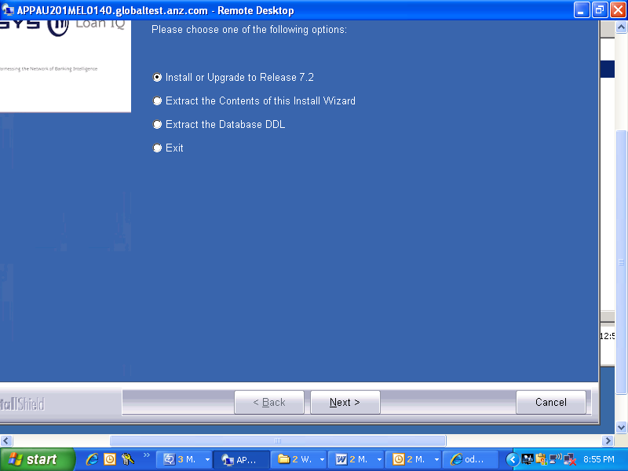

Screen2
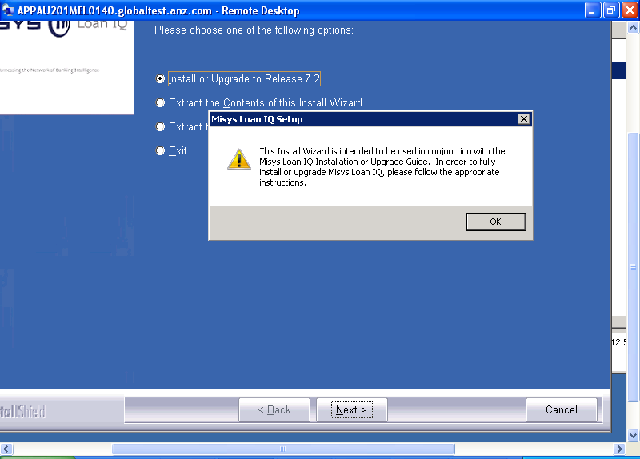
Press OK on the above active screen

Screen3: Select Database Option as below
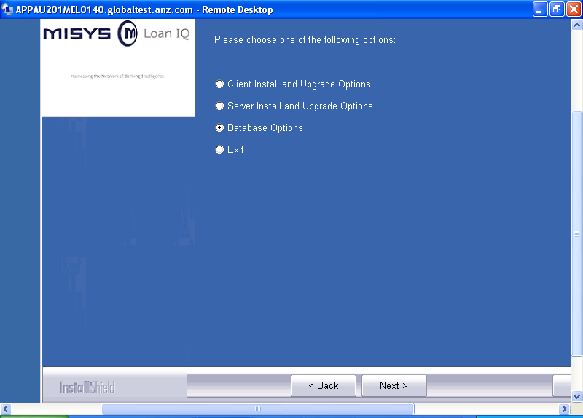

Screen4, Load New database for any new environment.

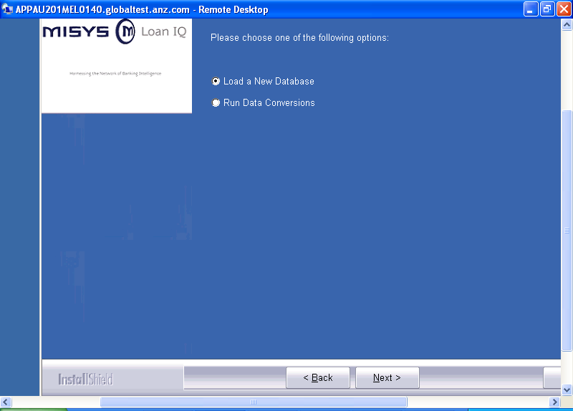

Screen5:
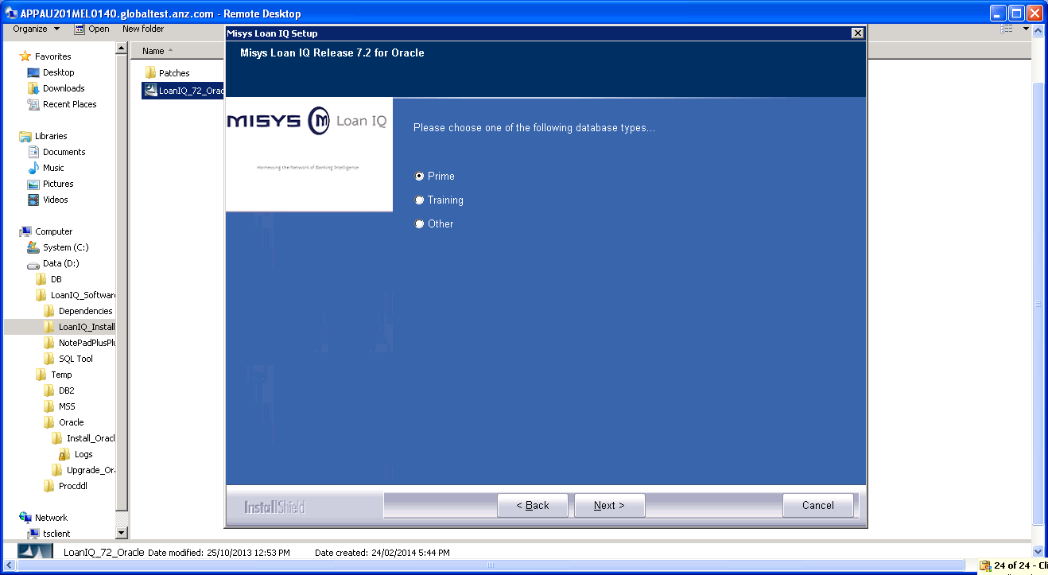

Screen 6: Create a temp folder for the DB extract in the local system.

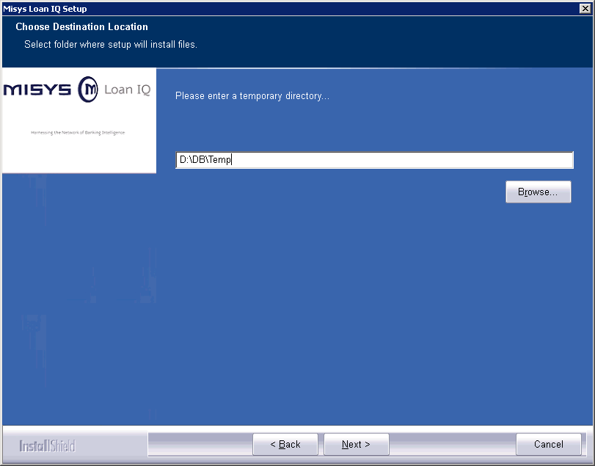

Screen7
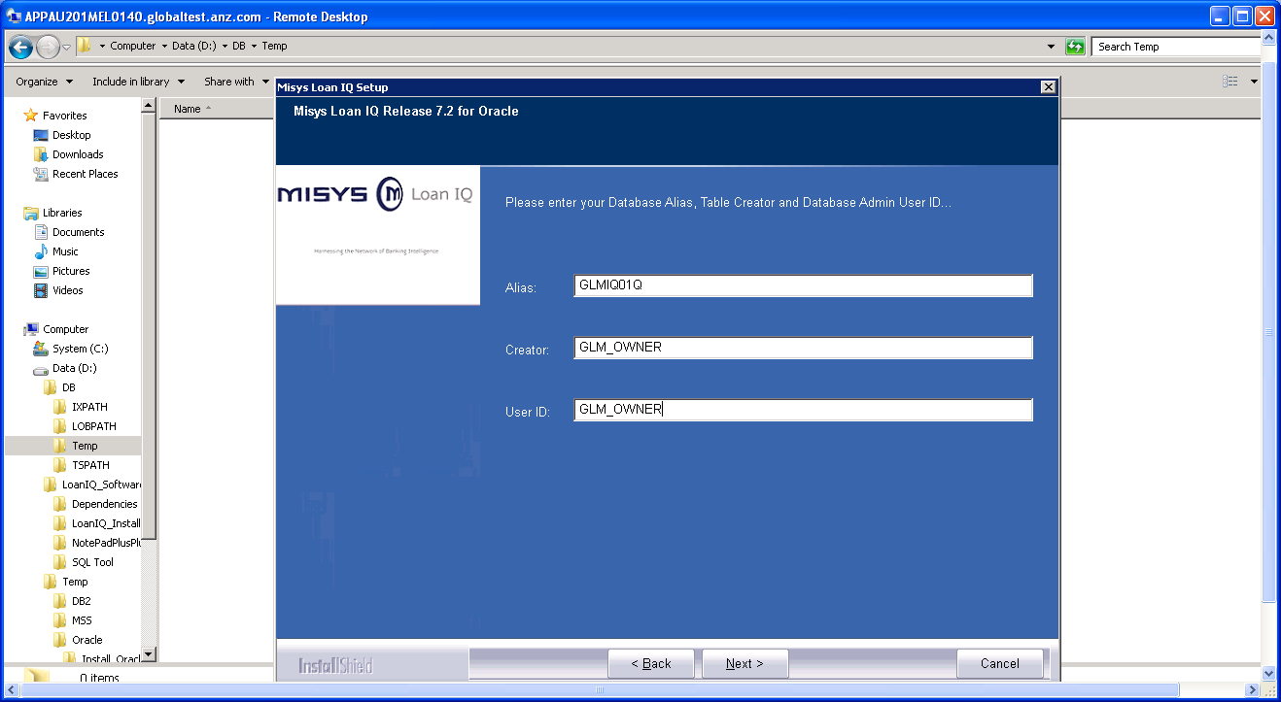

Screen8:
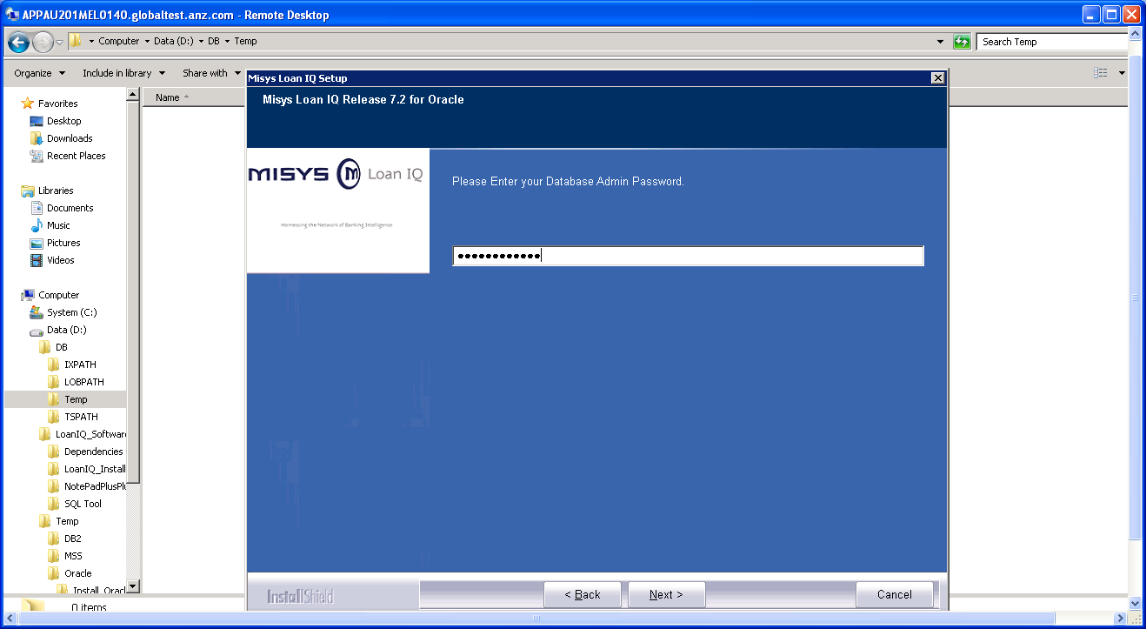

Screen9:
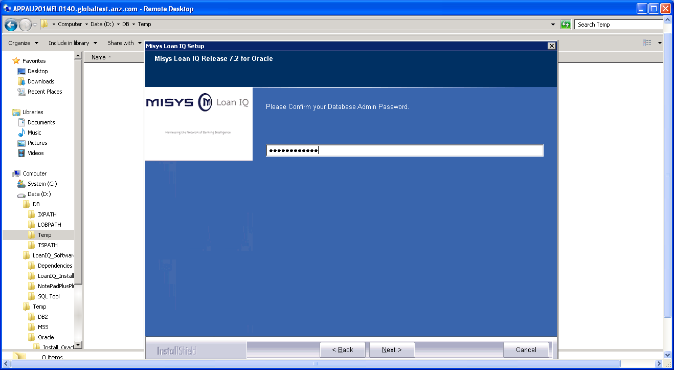

Screen10:
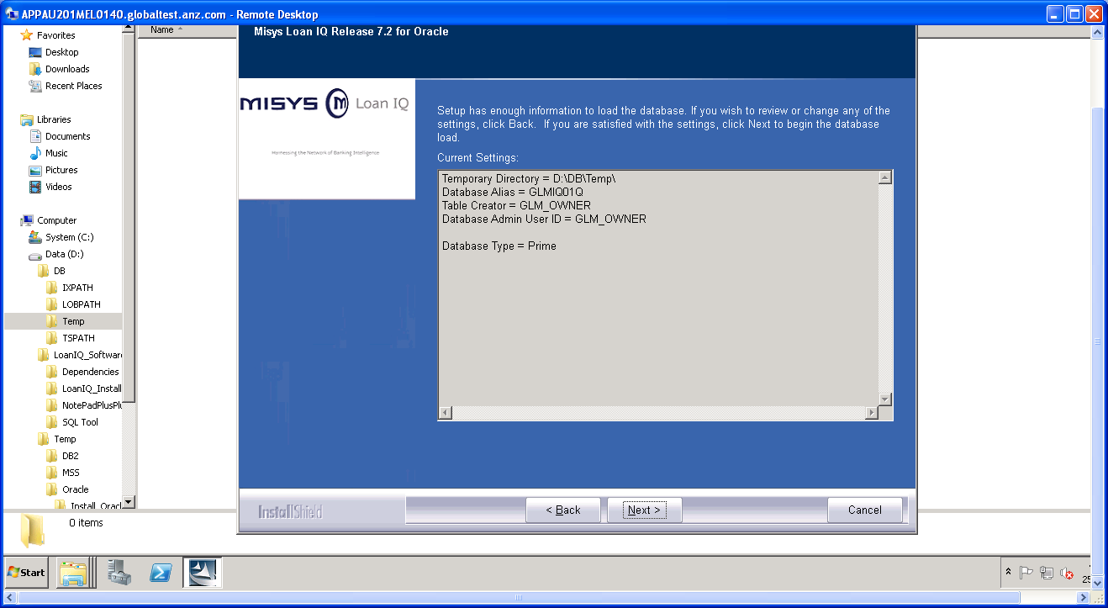

Switch to Loan IQ Installer for Server Installation:
Screen1
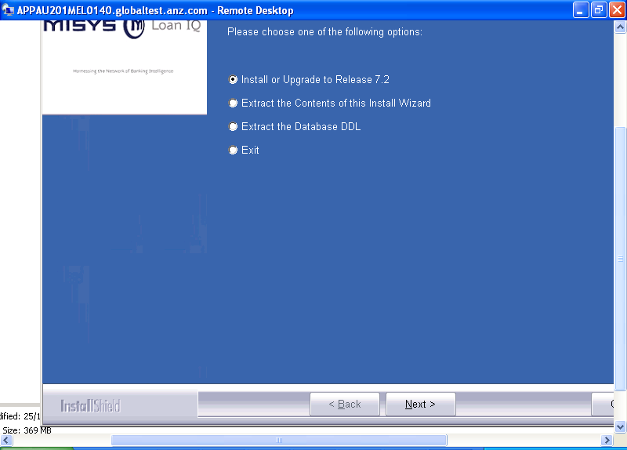

Screen2:
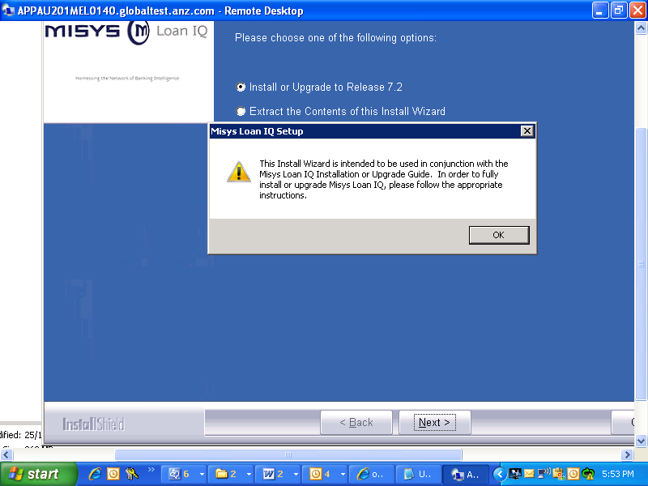

Screen3:
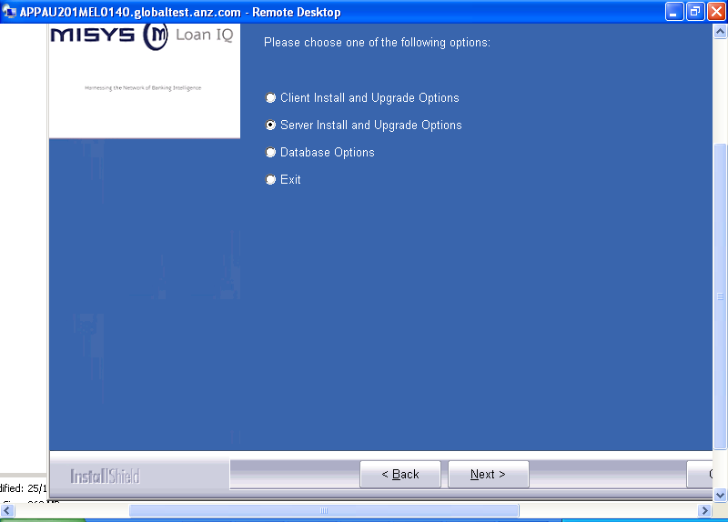
Screen4:
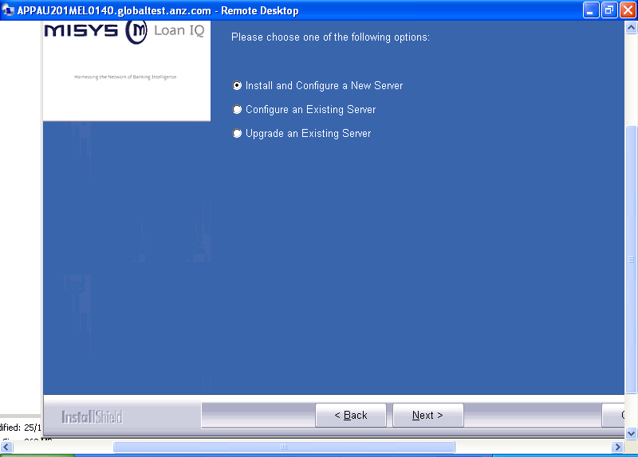
Screen5:

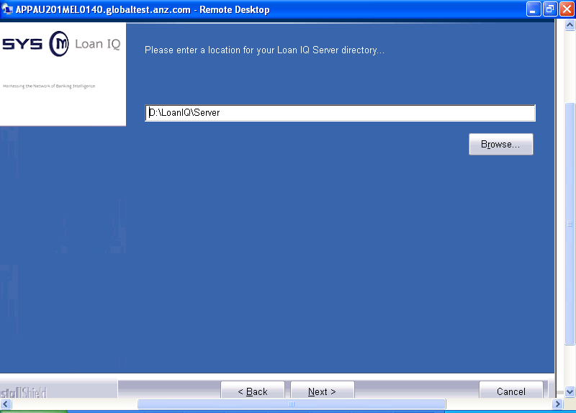

Screen6:
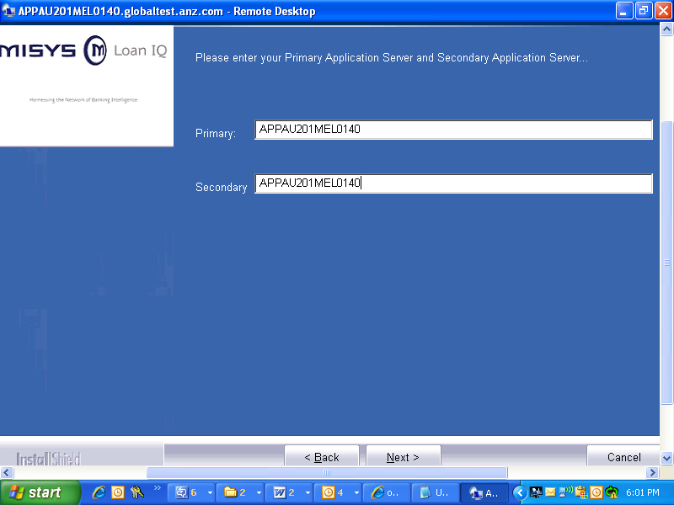

Screen7:
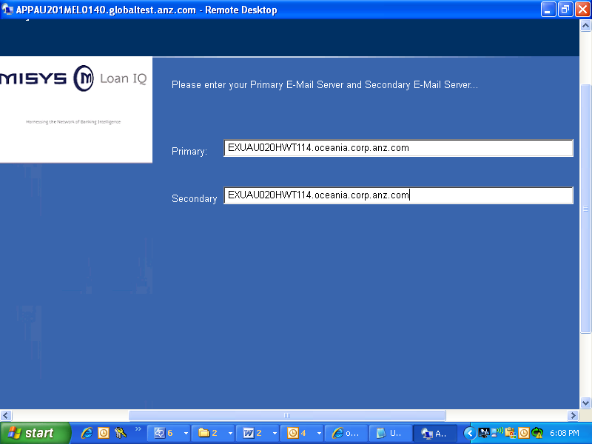

Screen7:
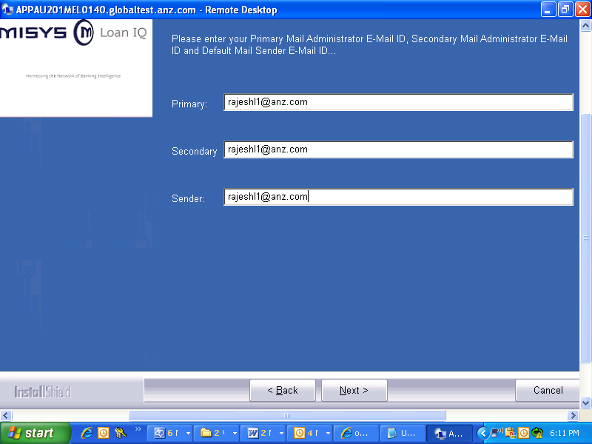

Screen8:
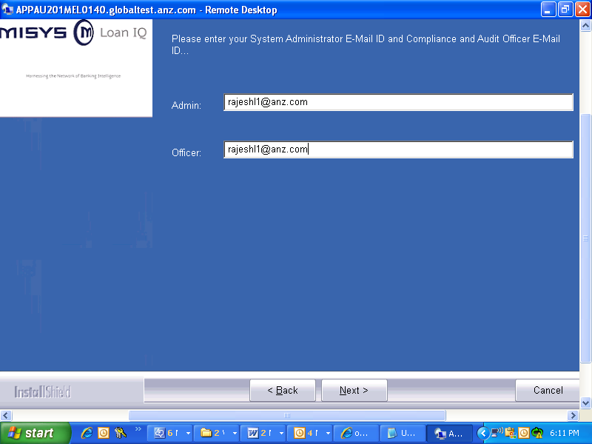
Scree9:
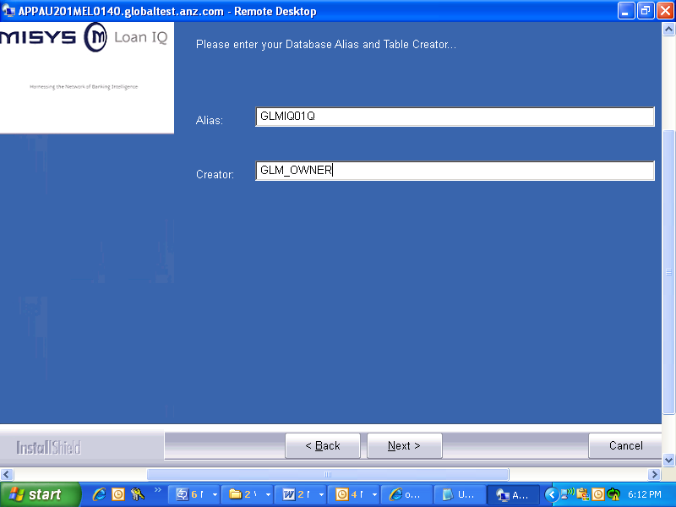

Screen10:
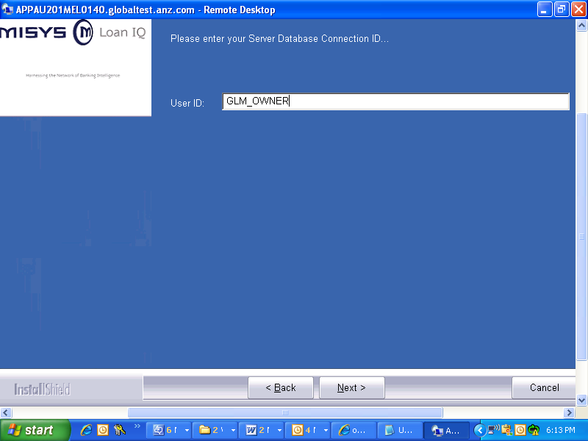
Screen11:
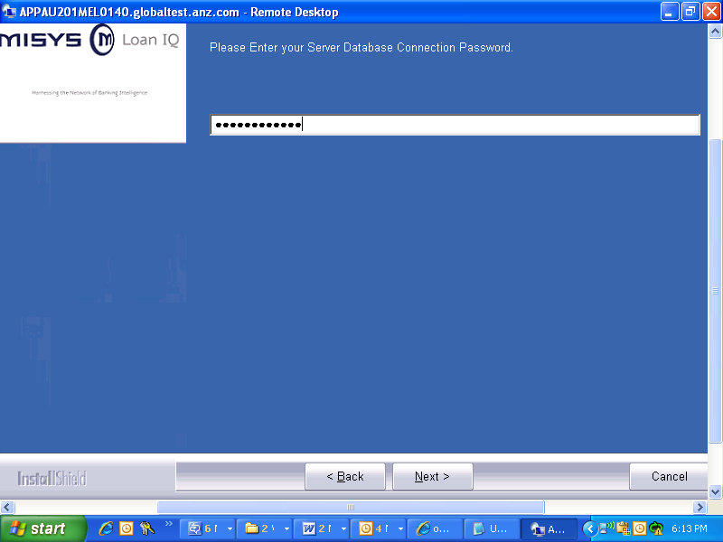
Screen12:
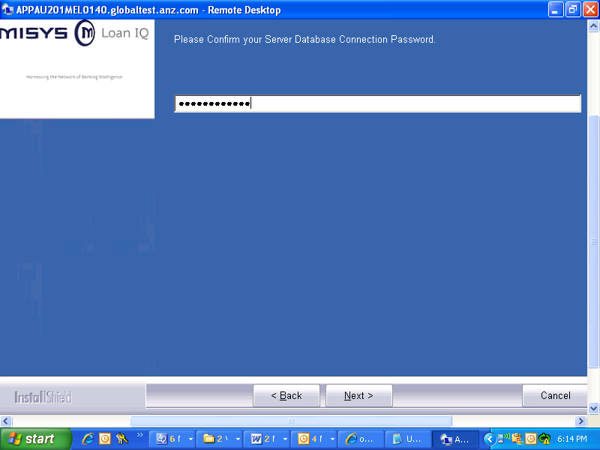
Screen13:
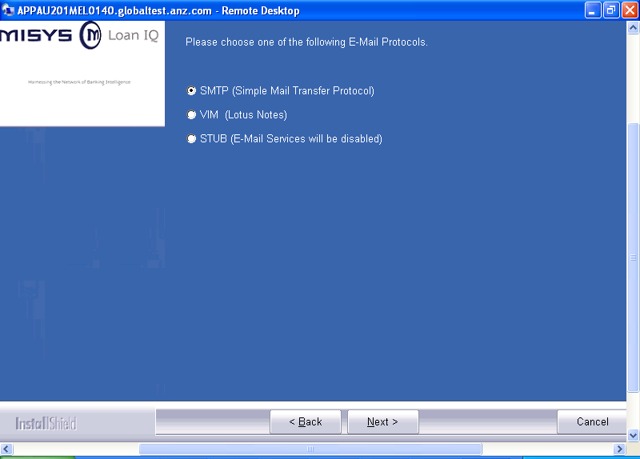

Screen14:
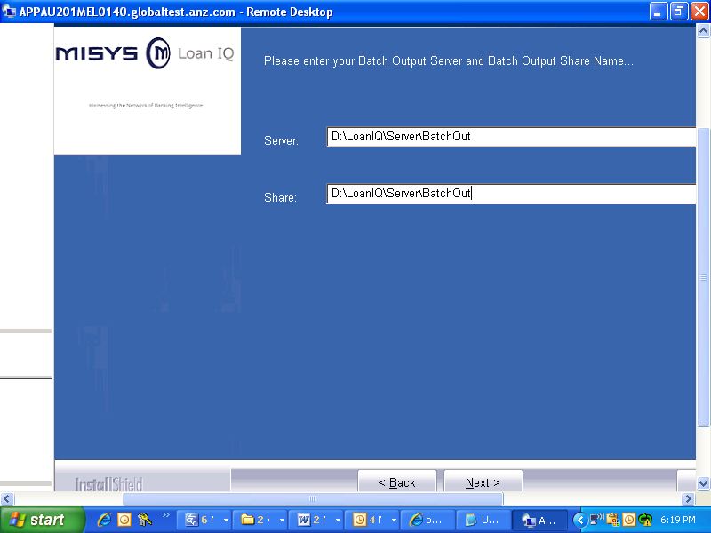

Screen15:
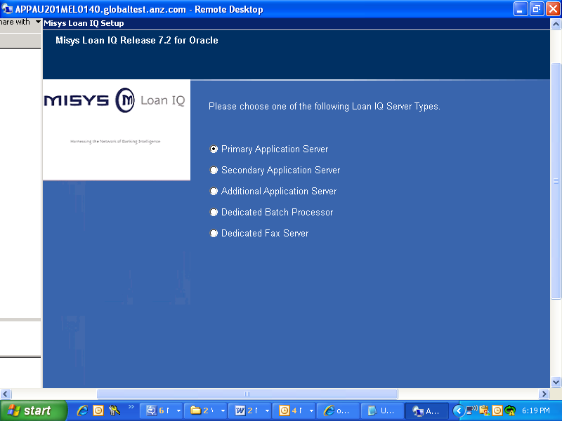

Screen14:
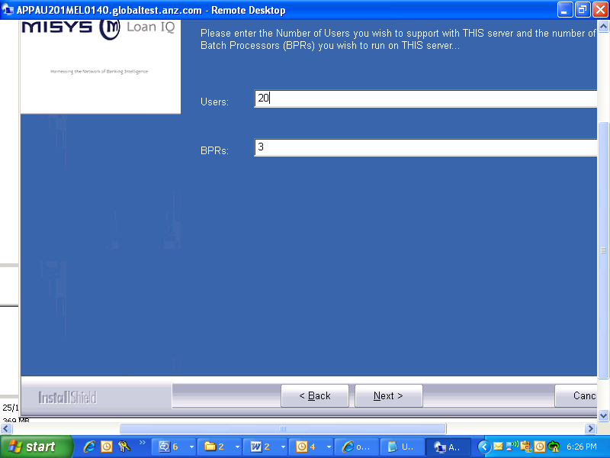

Screen16:
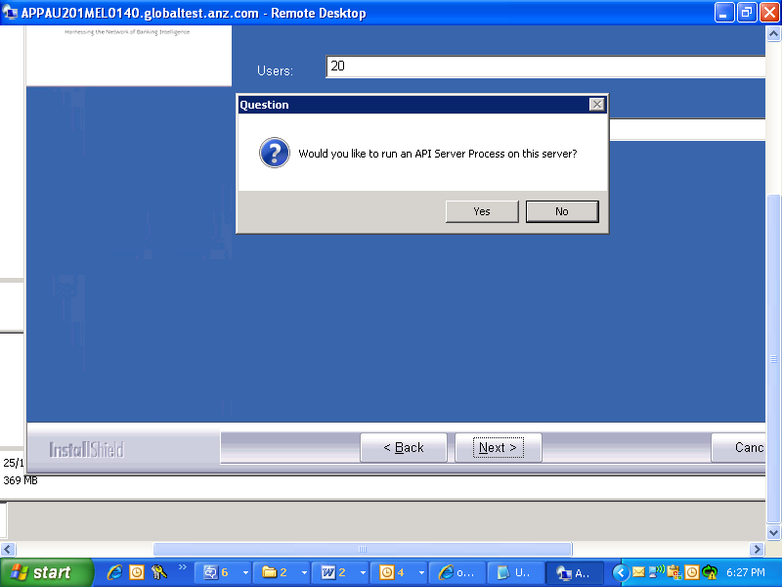

Just click yes on the above popup.
Screen17:
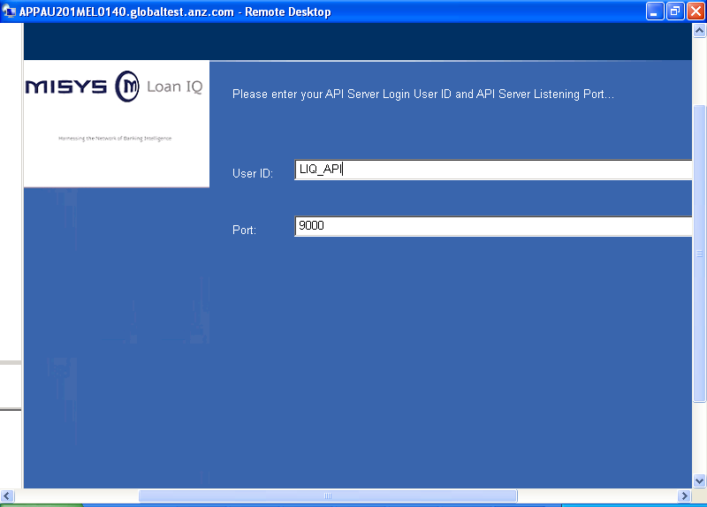

Screen18: Note:-In the below screen shot the service Name should be:LoanIQ

In runliq.cmd the service name should be same as given while installation.
Ex: For the below screen shot this is the corresponding config. In runliq.cmd
if /i "%retStatus%" == "Undefined" (
if "%LIQNamespace%" == "2020" (
call :Message System service '%LIQ_ServiceName%' is not installed, trying STARTLIQ
set LIQ_ServiceName=x2glmssvcdsa
call :CheckServiceStatus x2glmssvcdsa
)
)

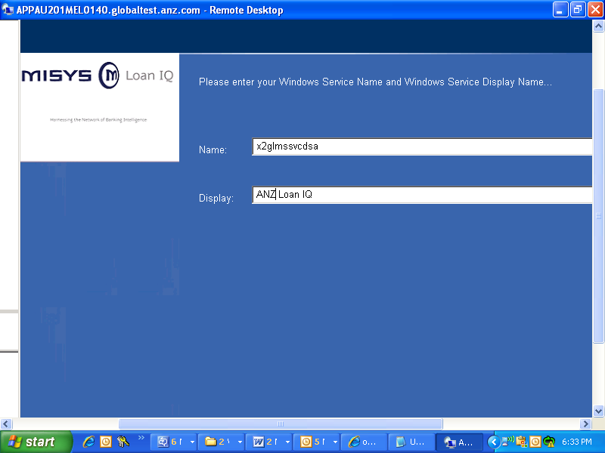

Screen19:
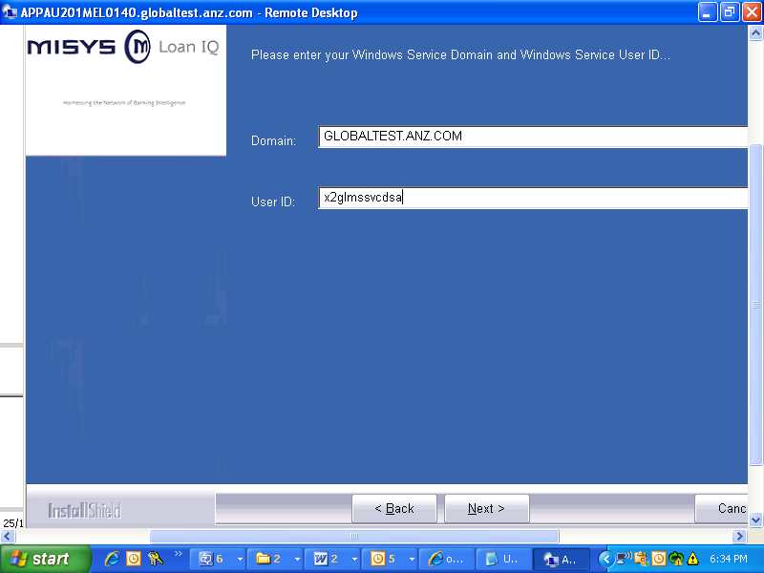

Screen20:
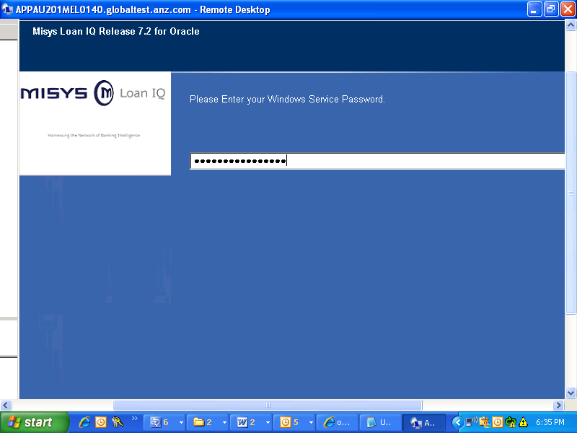

Screen21:
Server Directory = D:\LoanIQ\Server\
Primary Application Server = APPAU201MEL0140
Secondary Application Server = APPAU201MEL0140
Primary E-Mail Server = EXUAU020HWT114.oceania.corp.anz.com
Secondary E-Mail Server = EXUAU020HWT114.oceania.corp.anz.com
Primary E-Mail Administrator = rajeshl1@anz.com
Secondary E-Mail Administrator = rajeshl1@anz.com
E-Mail Sender = rajeshl1@anz.com
System Administrator = rajeshl1@anz.com
Compliance and Audit Officer = rajeshl1@anz.com
Database Alias = GLMIQ01Q
Table Creator = GLM_OWNER
Server Database Connection ID = GLM_OWNER
E-Mail Protocol = SMTP
Server Type = Primary
Number of Users = 20
Number of BPRs = 3
Windows Service Name = x2glmssvcdsa
Windows Service Display Name = ANZ Loan IQ
Windows Service Domain = GLOBALTEST.ANZ.COM
Windows Service User ID = x2glmssvcdsa
Batch Output Share = \\D:\LoanIQ\Server\BatchOut\D:\LoanIQ\Server\BatchOut
Start API Server = YES
API Server Login User ID = LIQ_API
API Server Listening Port = 9000
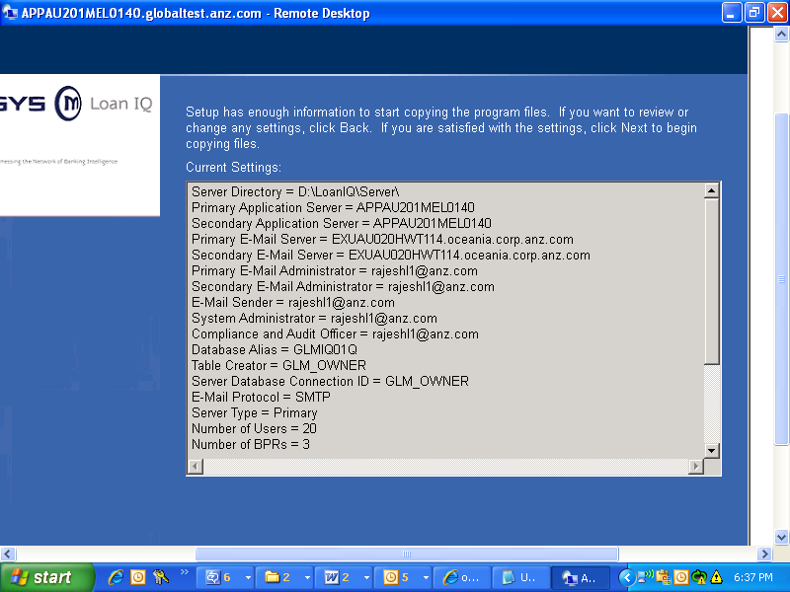

Configure Tomcat for Loan IQ
To connect to the application using the new HTTP based application server, you must configure the JEE application server. By default, Loan IQ provides the Tomcat/Apache J2EE application server. The following instructions to install the JDBC driver pertain to the default Tomcat application server.
Note: This is only required if you are configuring the optional HTTP Application server.
- Open the server\tomcat.ini file.
- Set java.home to point to your Java install directory.
- Set server.dir to point to the Loan IQ server directory as follows:
- Open the server\tomcat\conf\server.xml file and modify all ports to desired port numbers. Uncomment the SSL section and set the port number if required.
Notes:
- TLSv1.2 requires Java 7 with unlimited encryption modules installed.
- Additional Tomcat 7 configuration information can be found at http://tomcat.apache.org/tomcat-7.0-doc/index.html.
- Open the server\tomcat\conf\context.xml file and modify the Resource element to set the driverClassName, url, username, and password. These need to point to your database as follows:
- For Oracle copy the ojdbc6_g.jar or ojdbc6.jar from your Oracle installation into Server\Tomcat\lib and set the following properties.
driverClassName="oracle.jdbc.OracleDriver"
url="jdbc:oracle:thin:@//<db host>:<db port>/<db name>"
Additionally add the following parameter to the Resource:
initConnectionSqls="ALTER SESSION SET NLS_TIMESTAMP_FORMAT = 'YYYY-MM-DD HH24.MI.SS.FF6';ALTER SESSION SET NLS_DATE_FORMAT = 'YYYY-MM-DD HH24.MI.SS'"
The following is a sample connection pool resource configuration for Oracle.
<Resource
auth="Container"
defaultAutoCommit="false"
defaultTransactionIsolation="READ_COMMITTED"
initialSize="10"
maxActive="40"
maxIdle="10"
maxWait="-1"
name="jdbc/LiqCommonPool"
type="javax.sql.DataSource"

initConnectionSqls="ALTER SESSION SET NLS_TIMESTAMP_FORMAT = 'YYYY-MM-DD HH24.MI.SS.FF6';ALTER SESSION SET NLS_DATE_FORMAT = 'YYYY-MM-DD HH24.MI.SS'"
driverClassName="oracle.jdbc.OracleDriver"
url="jdbc:oracle:thin:@//<db host>:<db port>/<db name>"
username="<db user>"
password="db password>"
/>
- Open the Server\Tomcat\jrconf\JSqlAccessProperties.xml file and set the following:
- Set JSqlAccessJdbcClass, DBDefaultUserName, DBDefaultPassword, JSqlAccessJdbcUrl, and DBSchema according to the database selected above.
- Set SqlFilePath to point to the XML directory for your database. Below is an example for Oracle:
<entry key="SqlFilePath">${server.dir}/Oracle;config/transaction-config.xml</entry>
======Note: - below step is not done will be taken after Env. Sanity test====
- To encrypt the values in JSqlAccessProperties.xml follow these steps.
- Rename: Server\Tomcat\jrconf\JSqlAccessProperties.xml to Server\Tomcat\jrconf\JSqlAccessPropertiesOrig.xml
- Add the following key/value pair to Server\Tomcat\jrconf\JSqlAccessPropertiesOrig.xml
<entry key="Encrypted.Values">.*pass.*</entry>
- Run this command:
java.exe -cp lib\liq_apputils.jar EncryptProperties -in Server\Tomcat\jrconf\JSqlAccessPropertiesOrig.xml -out Server\Tomcat\jrconf\JSqlAccessProperties.xml
- Delete or backup Server\Tomcat\jrconf\JSqlAccessPropertiesOrig.xml
- For additional encryption options run this command:
java.exe -cp lib\liq_apputils.jar EncryptProperties -?
- Open the Server\Tomcat\jrconf\log4j.xml file and add
<appender name="file" class="org.apache.log4j.RollingFileAppender">
<param name="file" value="D:/LoanIQ/Server/Tomcat/logs/jackrabbit.log" /> <param name="maxFileSize" value="512MB" />
<param name="maxBackupIndex" value="50" />
<layout class="org.apache.log4j.PatternLayout">
<param name="ConversionPattern" value="%d{yyyy-MM-dd_HH:mm:ss.SSS} [%t] %p: %m%n" />
</layout>
</appender>

And make sure that you have the below <root > specified in the file.
<root>
<priority value ="Error" />
<appender-ref ref="console"></appender-ref>
<appender-ref ref="file"></appender-ref>
</root>

- In the server\liqsetenv_<host name>.cmd file add the following line which starts and stops Tomcat with the Loan IQ service:
set LIQ_RunTomcat=Y

Server configurations
- Ls2app.ini
a) Please verify the [Database] section (it should have all the DB details as below ex.)
Userid = GLM_OWNER
Password =EE53A79321912F4CD34FFAF553D06D0E9A1BE2EC53D06D0E9A1BE2EC53D06D0E9A1BE2EC53D06D0E
Alias = GLMIQ01Q
Schema = GLM_OWNER
Always Connect With Default Id = YES
XML SUBDIRECTORY = oracle

b) Add below section (make sure that you are giving right host ID and ports of webservices deployment)
[API Web Service]
URL = http://localhost:8080/liq_apiWebService/api/liq
Users = LIQ_API

Note:- The following is a sample configuration for the API web service to allow 2 specified Loan IQ users (with passwords) connect to an external web service location:

[API Web Service]
URL = http://apihost.bank.com:8080/liq_apiWebService/api/liq
Users = ADMIN01:Password123,ADMIN02:Password456
C)
[JAVA2SQL]
Appserver Interface = com.misys.liq.core.dbaccess.InProcessConnection
Input Resource=D:\LoanIQ\Server\Tomcat\jrconf\JSqlAccessProperties.xml

Basic Testing
  - Start Loan IQ Service.
  - Open cmd and navigate to server home directory and type below command.

D:\LoanIQ\Server>adm
REG @ APPAU201MEL0140 > HELP

ADM COMMANDS
------------
ALIAS [{Alias} [[USAGE:"{usage}"] {replaceWith}] ] List [add] command aliases.
HELP [{Command}|SEC] Show help for command(s) [SEC: show security levels].
QUIT End this program.
RECORD {Record File} Record log of session in file.
RECORDSTOP Stop recording to current file.
REM {Comment text} Enter remark (comment). No effect.
SCRIPT {Script File} Process commands from file.
SVC {ServiceName} Set process to administrate.
NODE {NodeName} Set remote computer to administrate.
PORT [{PortdaemPort}|0] Get[Override|Default] PortdaemPort of environment to a
FINDLIQ Find all Loan IQ nodes on this network.
ADMCP Set NODE/SVC to a running ADMCP in this environment.
LOCAL Set NODE to this computer.
PRI Set NODE to computer running Primary ADMCP.
SEC Set NODE to computer running Secondary ADMCP.
GOTO {PID|ServiceName} Set NODE/SVC to first pgm match on machine/env.
USER {UserID} Set NODE/SVC to SQLAcces that {UserID} is logged in.

REG COMMANDS
------------
ALIAS [{Alias} [[USAGE:"{usage}"] {replaceWith}] ] List [add] command aliases.
HELP [{Command}|SEC] Show help for command(s) [SEC: show security levels].
HALT [ { Exit code } ] Terminate process with exit code (default = 1223).
INIHELP List and describe INI parameters for this process.
INIRELOAD Reload parameters from INI file for this process.
INISET { ParmName } = { Value } Reset INI parameter ParmName to Value in this proc
LOGMSG { Text } Write { Text } to the server log.
SETENV { Env variable } [= { Value } ] Get [set] value of a process environment varia
TRACELEVEL [ { New Trace Level } ] Get [set] value of log trace level for this process.
CLEAR Clear stopped processes from process list.
FIND { Process ID|Name } Display SVC@ThisNode of first matching ALIVE process.
KILL [-restart] Shutdown system. Stop PROCREG and all processes. [The
PROTECT { Process ID|Name } Protect process by PID or (SVC)Name from STOP command.
QUIESCE { Process ID|Name } Quiesce process by PID or (SVC)Name. No new connection
REBOOT Shutdown system and reboot server.
RESTART { Process ID|Name } Restart processes by PID or (SVC)Name using original c
REVIVE { Process ID|Name } Revive a quiesced process by PID or (SVC)Name. Resume
SETCLOCK [ { Date } ] [ { Time } ] [UTC] Set clock in local time [UTC time]. Format: [YY
SHOW [ { matchSVC } ] List all processes [that begin with matchSVC] and show
TREE List all processes and show status in a tree view.
START { Command } [ { Args } ] Start new process using given Command and command Ar
STOP { Process ID|Name } [ { ExitCode } ] Terminate a running process by PID or (S
STOPTREE { Process ID|Name } [ { ExitCode } ] Terminate a process by PID or (SVC)Name
SYSINFO Show information obtained from the OS about the local
UNPROTECT { Process ID|Name } Remove protection for process by PID or (SVC)Name.
VERSION Show Product Version information.

REG @ APPAU201MEL0140 > show

APPAU201MEL0140 PROCESS LIST info - sized for 3000 entries

SVC PID Started Last Active Status Command
-----------------------------------------------------------------------------------------
ADMCP 2076 02-26_17:44:01 02-26_18:05:25 Alive ADMCP
ADMCPMON 1224 02-26_17:44:00 02-26_17:44:01 Alive ADMCPMON
ALCONMON 3756 02-26_17:43:40 02-26_17:43:40 Alive ALCONMON
ALERTCON 3092 02-26_17:43:40 ?? Alive ALERTCON
ALERTMON 3152 02-26_17:43:26 02-26_17:43:27 Alive ALERTMON
BATCHDQ 3444 02-26_17:44:16 02-26_18:05:33 Alive BATCHDQ -all
BATDQMON 2596 02-26_17:44:16 02-26_17:44:16 Alive BATDQMON
BCP 2732 02-26_17:44:08 02-26_18:04:18 Alive BCP
BCPMON 3552 02-26_17:44:06 02-26_17:44:07 Alive BCPMON
BPR_1 3412 02-26_17:44:22 02-26_18:04:16 Alive BPR -seq 1 -ini LS2APP.INI -sec
BPR_2 2008 02-26_17:44:22 02-26_18:04:17 Alive BPR -seq 2 -ini LS2APP.INI -sec
BPR_3 2740 02-26_17:44:23 02-26_18:04:18 Alive BPR -seq 3 -ini LS2APP.INI -sec
BPRSVMON 3588 02-26_17:44:21 02-26_18:05:22 Alive BPRSVMON -sect BPRNT -svcs 3
FASTCGIMON 5032 02-26_17:44:53 02-26_17:44:53 Alive PROCMON -svcname FASTCGIMON -sv
FAXDBMON 4316 02-26_17:44:42 02-26_17:44:42 Alive FAXDBMON
LOGGER 3456 02-26_17:43:14 02-26_18:05:34 Alive LOGGER -reg
LOGRMON 880 02-26_17:43:13 02-26_17:43:14 Alive LOGRMON
LS2ALERT 1752 02-26_17:43:28 ?? Alive LS2ALERT
LS2FAXDB 4396 02-26_17:44:42 ?? Alive LS2FAXDB -reg
MAILSRV 3972 02-26_17:44:27 ?? Alive MAILSRV -ini LS2APP.INI -sect M
MSRVMON 3332 02-26_17:44:26 02-26_18:05:25 Alive MSRVMON -sect MAILSRV
NCP 652 02-26_17:44:12 ?? Alive NCP
NCPMON 2332 02-26_17:44:11 02-26_17:44:12 Alive NCPMON
PORTDAEM 1808 02-26_17:43:09 02-26_17:43:09 Alive PORTDAEM
PORTDMON 2652 02-26_17:43:08 02-26_17:43:08 Alive PORTDMON
REGMON 3696 02-26_17:43:21 02-26_17:43:22 Alive REGMON
SQLACCES_1 2796 02-26_17:44:32 ?? Alive SQLACCES -seq 1 -ini LS2APP.INI
SQLACCES_2 3724 02-26_17:44:39 ?? Alive SQLACCES -seq 2 -ini LS2APP.INI
SQLACCES_3 4112 02-26_17:44:39 ?? Alive SQLACCES -seq 3 -ini LS2APP.INI
SQLACCES_4 4144 02-26_17:44:40 ?? Alive SQLACCES -seq 4 -ini LS2APP.INI
SQLACCES_5 4176 02-26_17:44:40 ?? Alive SQLACCES -seq 5 -ini LS2APP.INI
SQLACCES_6 4208 02-26_17:44:41 ?? Alive SQLACCES -seq 6 -ini LS2APP.INI
SQLACCES_7 4240 02-26_17:44:41 ?? Alive SQLACCES -seq 7 -ini LS2APP.INI
SQLACCES_8 4276 02-26_17:44:42 ?? Alive SQLACCES -seq 8 -ini LS2APP.INI
SQLACCES_9 4360 02-26_17:44:42 ?? Alive SQLACCES -seq 9 -ini LS2APP.INI
SQLACCES_10 4420 02-26_17:44:43 ?? Alive SQLACCES -seq 10 -ini LS2APP.IN
SQLACCES_11 4500 02-26_17:44:43 ?? Alive SQLACCES -seq 11 -ini LS2APP.IN
SQLACCES_12 4556 02-26_17:44:44 ?? Alive SQLACCES -seq 12 -ini LS2APP.IN
SQLACCES_13 4588 02-26_17:44:44 ?? Alive SQLACCES -seq 13 -ini LS2APP.IN
SQLACCES_14 4648 02-26_17:44:46 ?? Alive SQLACCES -seq 14 -ini LS2APP.IN
SQLACCES_15 4680 02-26_17:44:47 ?? Alive SQLACCES -seq 15 -ini LS2APP.IN
SQLACCES_16 4768 02-26_17:44:48 ?? Alive SQLACCES -seq 16 -ini LS2APP.IN
SQLACCES_17 4808 02-26_17:44:49 ?? Alive SQLACCES -seq 17 -ini LS2APP.IN
SQLACCES_18 4864 02-26_17:44:49 ?? Alive SQLACCES -seq 18 -ini LS2APP.IN
SQLACCES_19 4896 02-26_17:44:50 ?? Alive SQLACCES -seq 19 -ini LS2APP.IN
SQLACCES_20 4932 02-26_17:44:50 ?? Alive SQLACCES -seq 20 -ini LS2APP.IN
SQLAPMON 4004 02-26_17:44:31 02-26_18:04:49 Alive SQLAPMON -sect SQLAcces -svcs 2
TOMCATMON 4720 02-26_17:44:48 02-26_18:05:29 Alive PROCMON -svcname TOMCATMON -chi

48 entries found

REG @ APPAU201MEL0140 >

  - Testing tomcat, by default it should run with the service and if you open http://localhost:8080/ you should be able to see tomcat home page,
  - And if not go to command prompt and at tomcat home/bin>Catalina.bat start
  - Repeat the step 3.
  - It should be as below, if asked for password give UN:tomcat and PW: tomcat
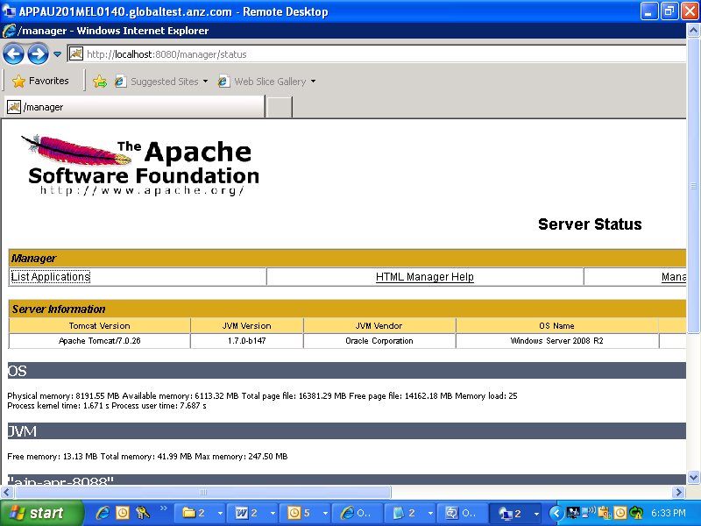
  - Click on list applications. You should be able to see Jackrabbit and LIQ_APIWebservice with running status as True.
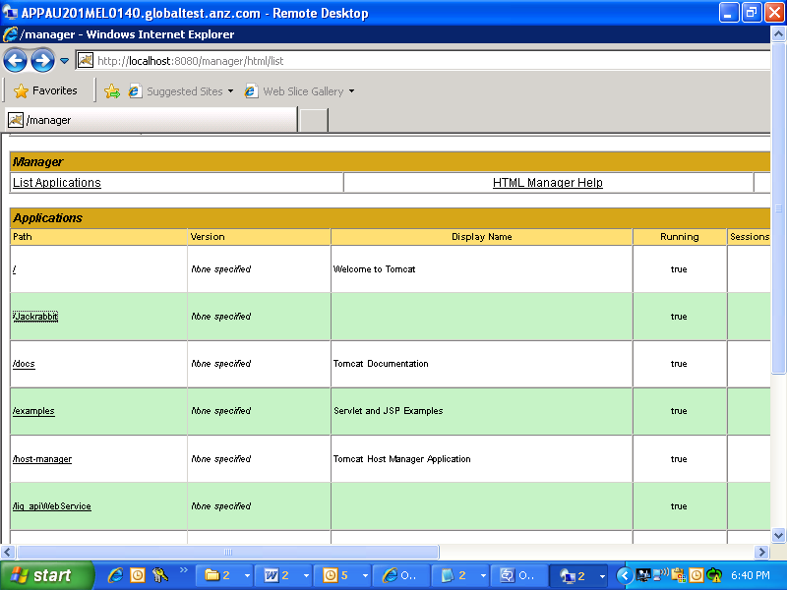
  - Confirmation check, click on jackrabbit, you should get
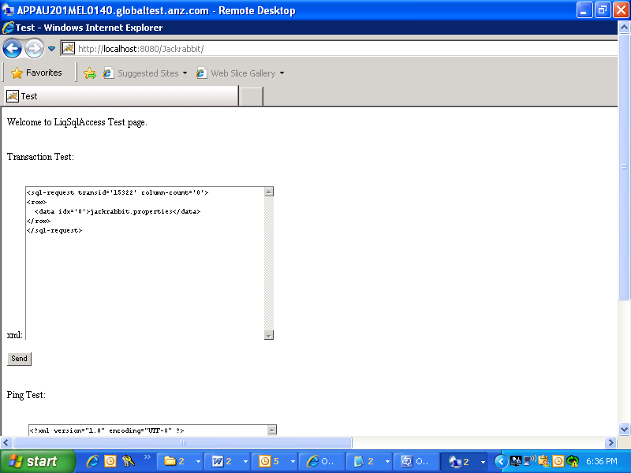

Errors: -
1. You may encounter below errors while starting the Loan IQ service or a particular service.
Service (ANZ loan IQ service) is not starting and the event logs as below.
Workaround:- Need to uninstall the SCOM agent from the App box.
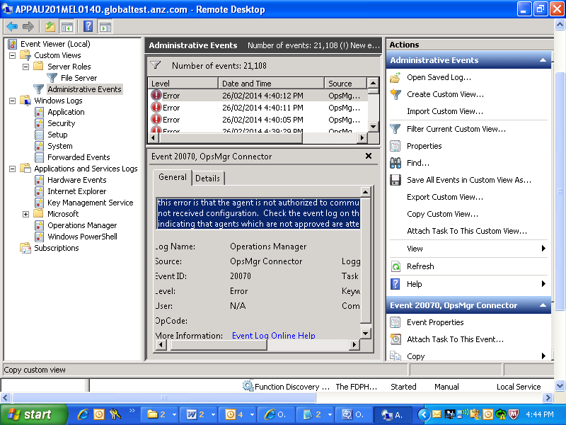

Observations: ANZ Loan IQ Service is not showing the status in the services but it runs as expected.

- 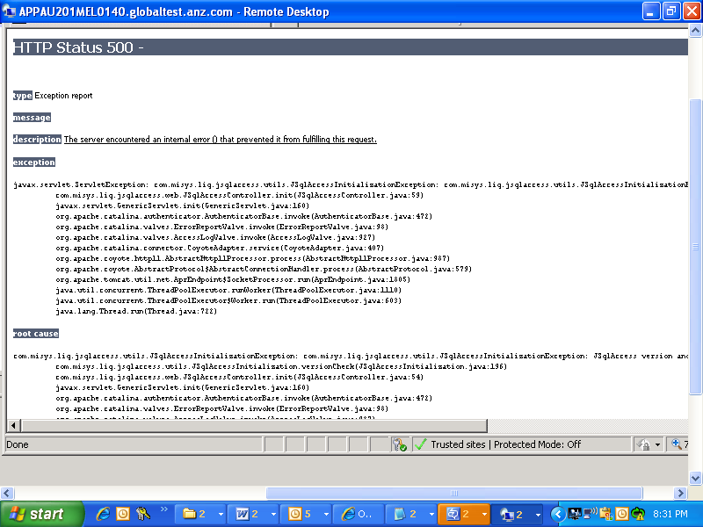
type Exception report
message
description The server encountered an internal error () that prevented it from fulfilling this request.
exception
javax.servlet.ServletException: com.misys.liq.jsqlaccess.utils.JSqlAccessInitializationException: com.misys.liq.jsqlaccess.utils.JSqlAccessInitializationException: JSqlAccess version and database LoanIQ version mismatch. ( 7.2.6.0 != 7.2.4.0 )
com.misys.liq.jsqlaccess.web.JSqlAccessController.init(JSqlAccessController.java:59)
javax.servlet.GenericServlet.init(GenericServlet.java:160)
org.apache.catalina.authenticator.AuthenticatorBase.invoke(AuthenticatorBase.java:472)
org.apache.catalina.valves.ErrorReportValve.invoke(ErrorReportValve.java:98)
org.apache.catalina.valves.AccessLogValve.invoke(AccessLogValve.java:927)
org.apache.catalina.connector.CoyoteAdapter.service(CoyoteAdapter.java:407)
org.apache.coyote.http11.AbstractHttp11Processor.process(AbstractHttp11Processor.java:987)
org.apache.coyote.AbstractProtocol$AbstractConnectionHandler.process(AbstractProtocol.java:579)
org.apache.tomcat.util.net.AprEndpoint$SocketProcessor.run(AprEndpoint.java:1805)
java.util.concurrent.ThreadPoolExecutor.runWorker(ThreadPoolExecutor.java:1110)
java.util.concurrent.ThreadPoolExecutor$Worker.run(ThreadPoolExecutor.java:603)
java.lang.Thread.run(Thread.java:722)

Solution to the above error: update the version of DB to match with your server version. Sample query is as below.
update TLS_ENVIRONMENT set ENV_TXT_VAR_VALUE='6.0' where ENV_NME_VAR_NAME='Service Pack';

Install Client

Go to installer folder and double click on the installer exe, you will get the below screen.
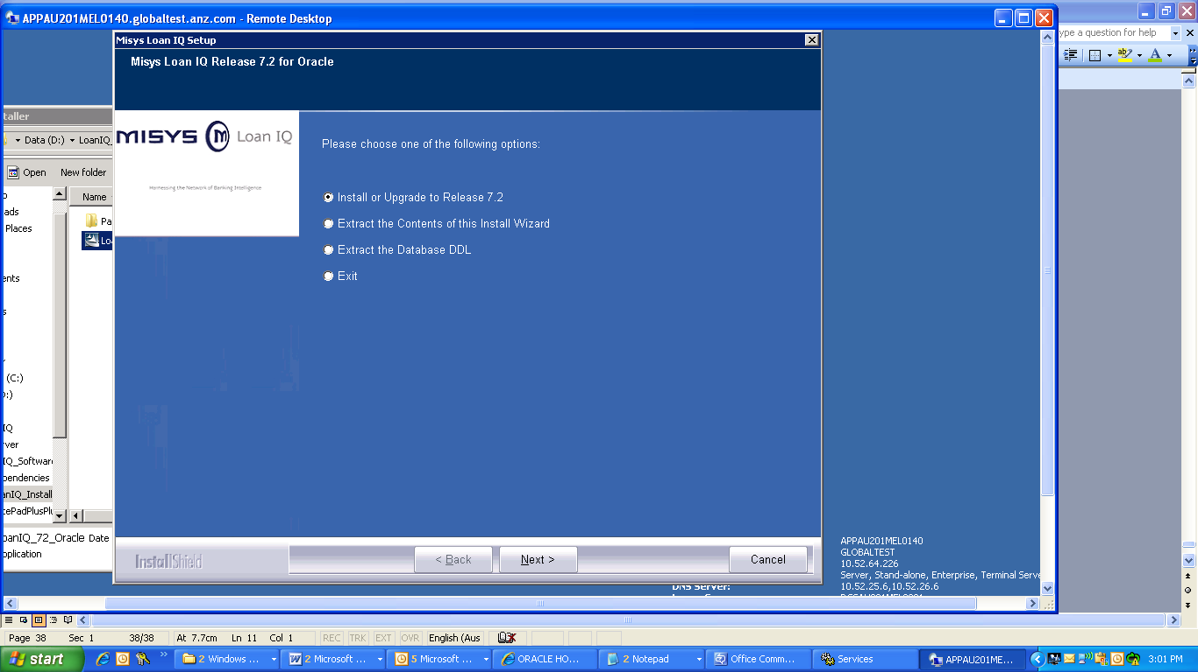
2.

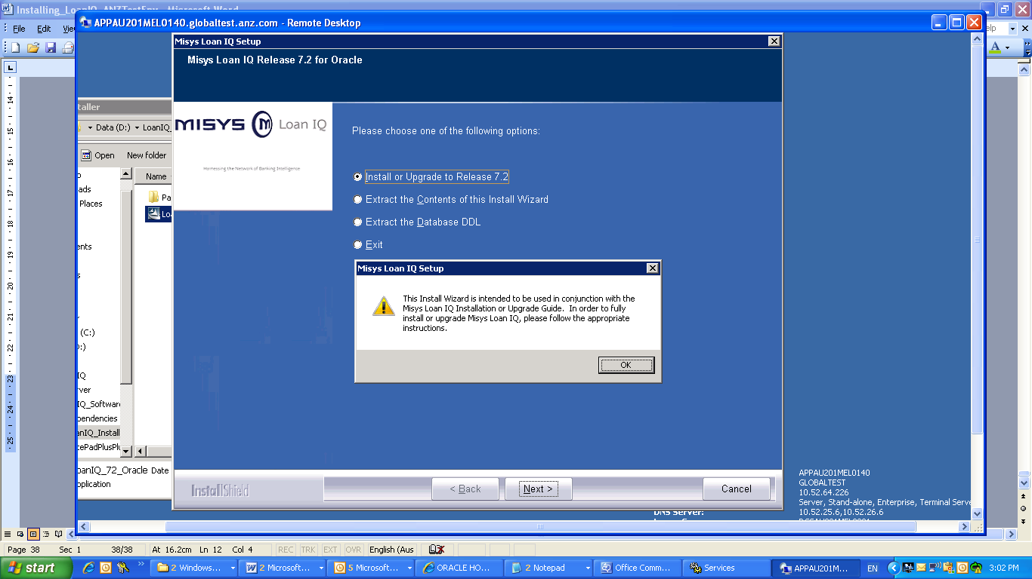
Screen3:
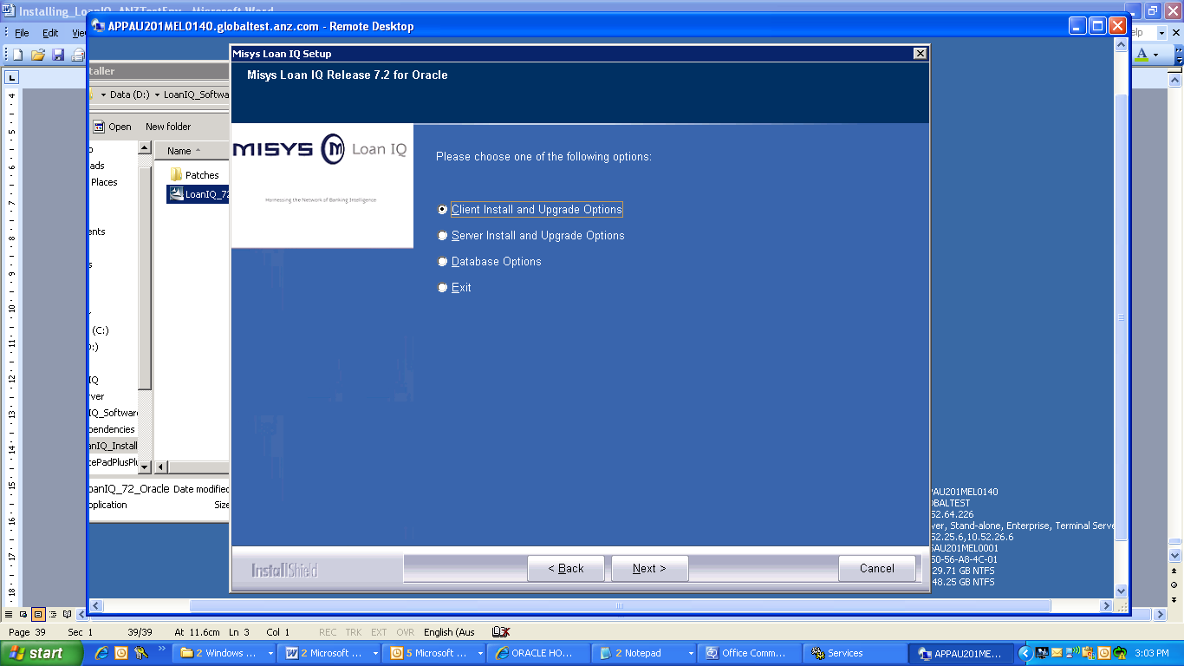
Screen4:
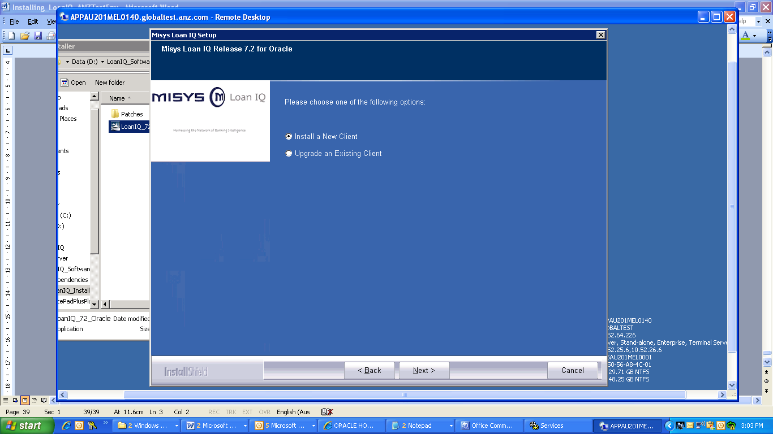
Screen5
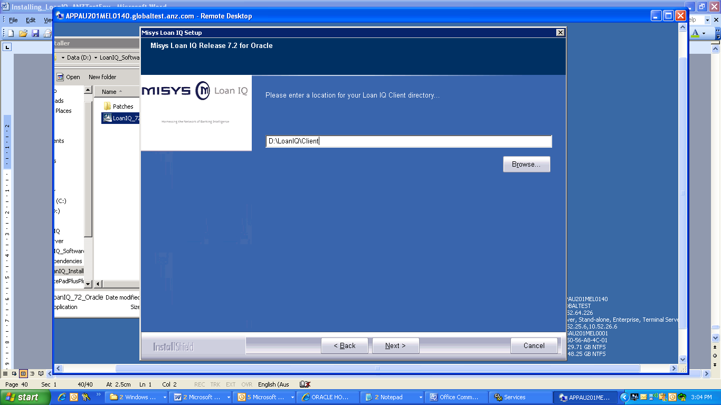
Screen6:
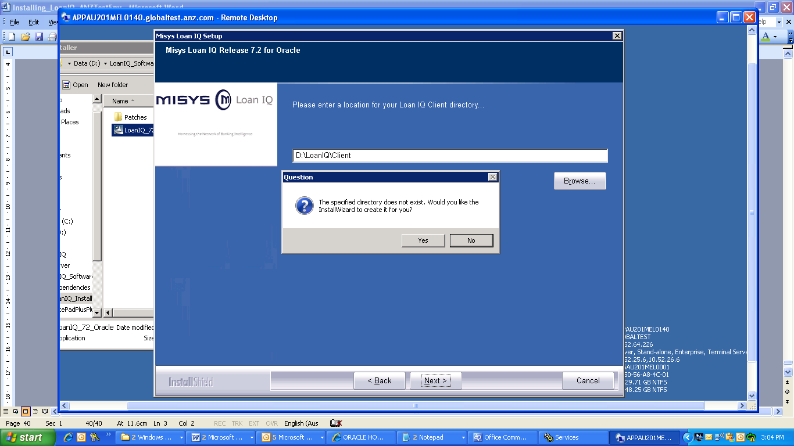
Screen7:

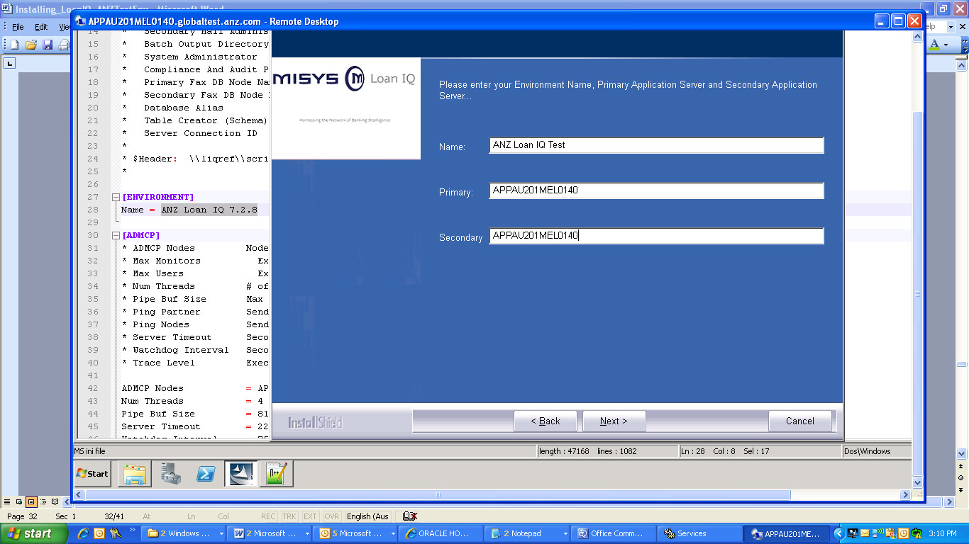

Screen 8:
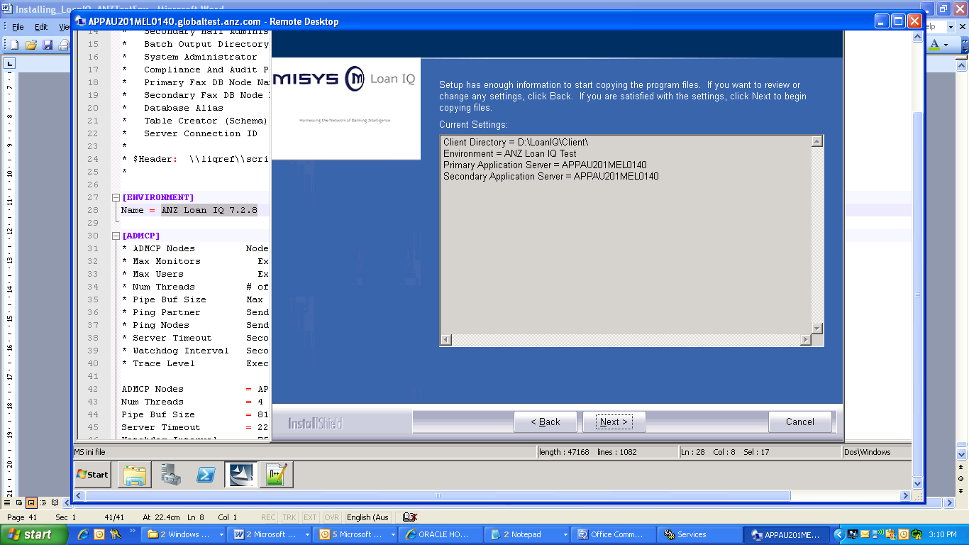
Screen9:
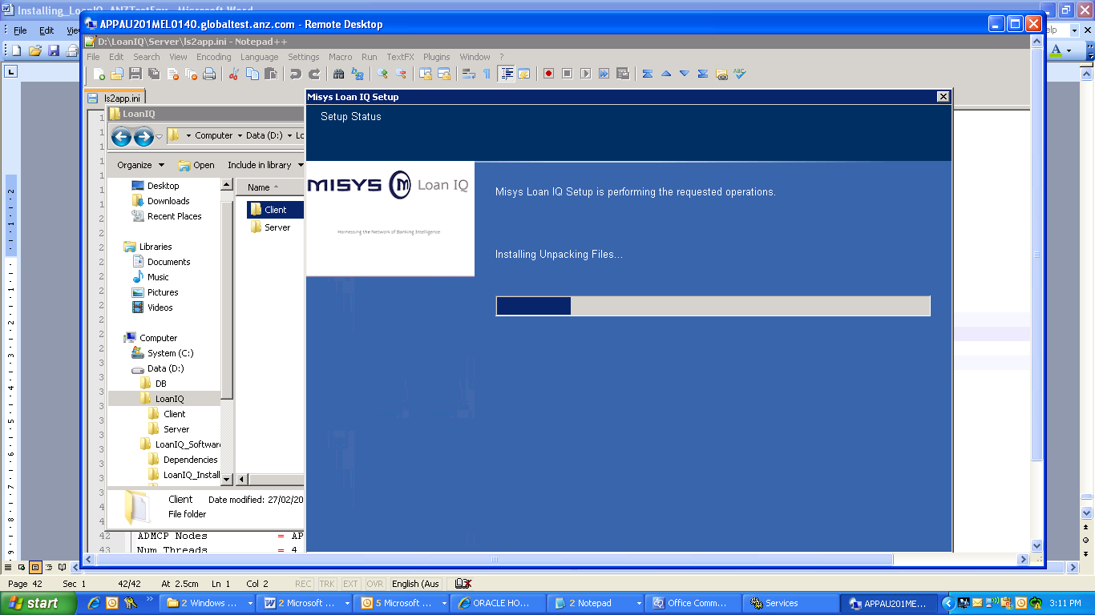

Extraction will happen in C drive only and it will show path as c drive only but exact installation will happen in D drive as mention in below screenshot. So pls don’t cancel installation.

Screen10:
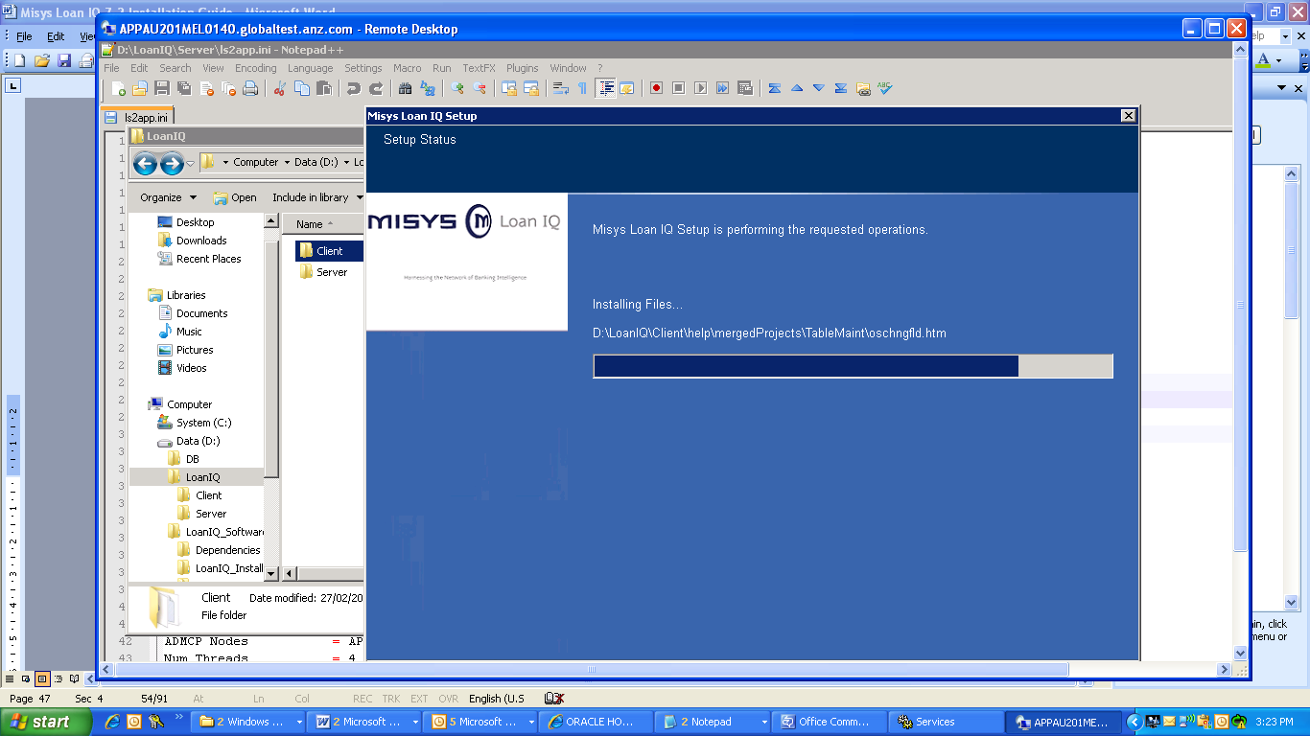

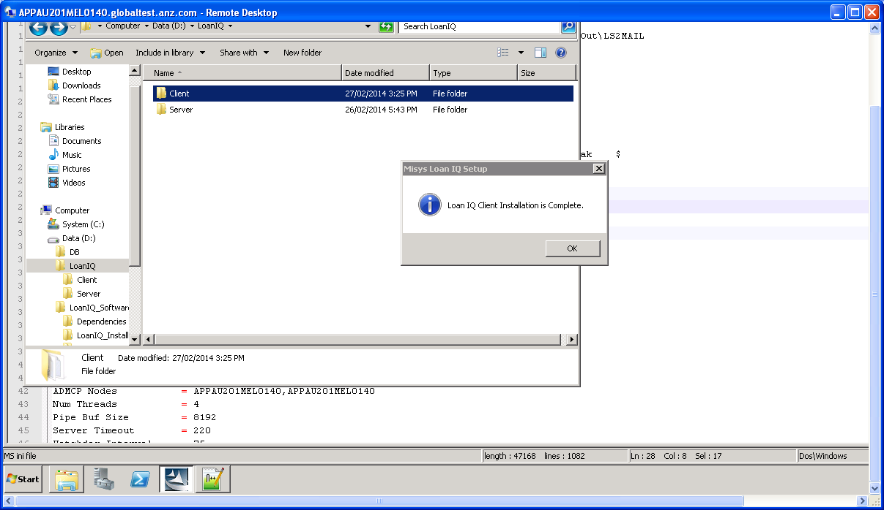

Make the following changes to Ls2app.ini in the client folder
Add
[JAVA2SQL]
Appserver Interface =HTTP
Client Type = rich
Input Resource =http://APPAU201MEL0140:8080/liq_coreApplicationServer/LoanIQCoreServlet
Ping Frequency = 10
Client Issues and resolutions:
Java not set, while trying to launch client if u have below error then
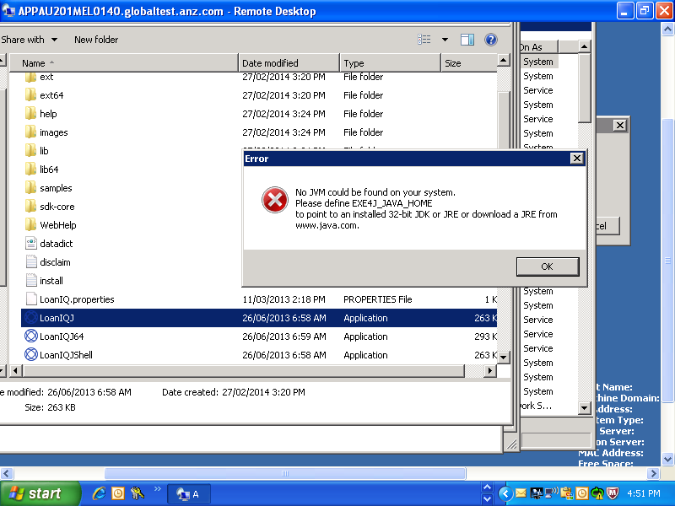

While log-in using client,
1. If you get popup saying that “Server error: user ID is not valid please contact your administrator”.
If you increase the log level to Debug you get this error in:
l-2-thread-1] INFO: loadXMLFromClasspath: xml: 0, named: 49
2014-02-27_19:21:23.296 [pool-2-thread-1] INFO: loaded config/transaction-config.xml
2014-02-27_19:21:23.421 [pool-2-thread-1] DEBUG: transaction not found 10970, could not set type 'com.misys.liq.jsqlaccess.transactions.config.Execution@e7c68e'
2014-02-27_19:21:23.421 [pool-2-thread-1] DEBUG: transaction not found 10980, could not set type 'com.misys.liq.jsqlaccess.transactions.config.Execution@e7c68e'
2014-02-27_19:21:23.421 [pool-2-thread-1] DEBUG: transaction not found 10990, could not set type 'com.misys.liq.jsqlaccess.transactions.config.Execution@e7c68e'
2014-02-27_19:21:23.421 [pool-2-thread-1] DEBUG: transaction not found 12581, could not set type 'com.misys.li

Resolution: this is because application is not able to find the transactions xml’s so give the xml path in the JSQLACCESSproperties.xml in the given tag.

Ex: - <entry key="SqlFilePath">D:/LoanIQ/Server/oracle;config/transaction-config.xml</entry>

2. IF you get “Server error: user ID is not valid please contact your administrator”.

And jackrabbit is giving this error:
2014-02-27_19:44:50.494 [http-apr-8080-exec-7] DEBUG: execute sql jar:file:/D:\LoanIQ\Server\Tomcat\temp\loaniq_trans_1169484586296233695.jar!/login/QueryUserPassword.xml, rc = 1
2014-02-27_19:44:50.494 [http-apr-8080-exec-7] ERROR: 1. doPost error: 2 - User Authentication Error for Login ID loaniq01
com.misys.liq.jsqlaccess.login.LoginException: User Authentication Error for Login ID loaniq01
at com.misys.liq.jsqlaccess.login.LoginAuthLoanIQ.doThrow(LoginAuthLoanIQ.java:607)
at com.misys.liq.jsqlaccess.login.LoginAuthLoanIQ.authenticateUser(LoginAuthLoanIQ.java:148)
at com.misys.liq.jsqlaccess.login.LoginAuthLoanIQ.authenticateUser(LoginAuthLoanIQ.java:62)
at com.misys.liq.jsqlaccess.login.JSqlAccessLoginHelper.onlineAuthentication(JSqlAccessLoginHelper.java:1096)
at com.misys.liq.jsqlaccess.web.JSqlAccessLoginAction.login(JSqlAccessLoginAction.java:58)
at com.misys.liq.jsqlaccess.web.JSqlAccessTransactionDispatcher.onlineTransactionExecution(JSqlAccessTransactionDispatcher.java:48)
at com.misys.liq.jsqlaccess.web.JSqlAccessController.doPost(JSqlAccessController.java:142)
at javax.servlet.http.HttpServlet.service(HttpServlet.java:641)

Resolution: this is because the crypto method by default is different from the method specified it’s the jsqlproperties.xml,

CryptoMethod is changed from
<entry key="CryptoMethod">AES</entry> to <entry key="CryptoMethod">XOR</entry>

Installing Licence File:

Basic Services:
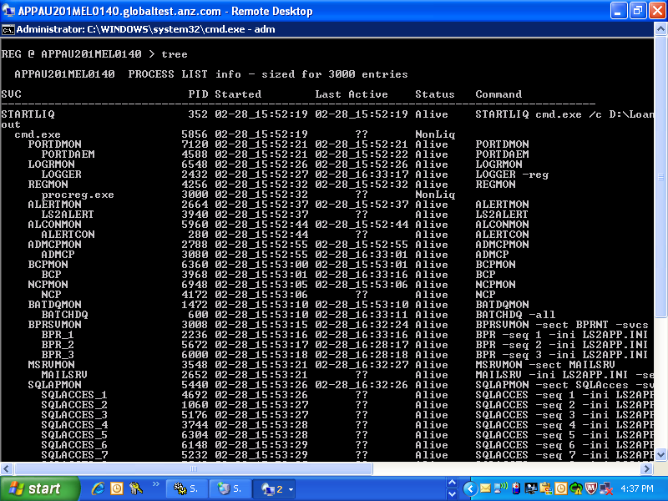
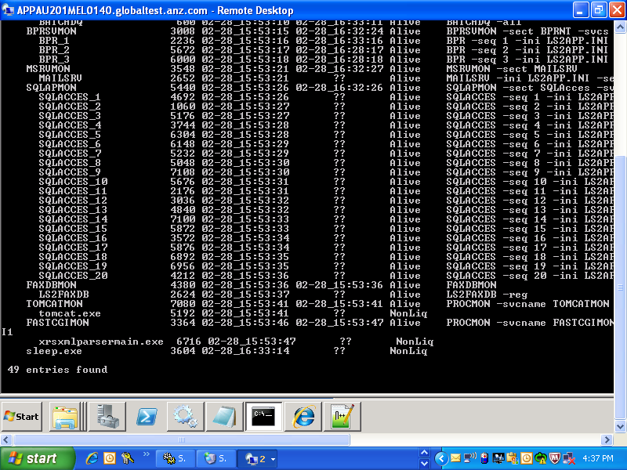

Tomcat Service Creation:

D:\LoanIQ\Server\Tomcat\bin>service.bat install ANZLoanIQTomcat
Installing the service 'ANZLoanIQTomcat' ...
Using CATALINA_HOME: "D:\LoanIQ\Server\Tomcat"
Using CATALINA_BASE: "D:\LoanIQ\Server\Tomcat"
Using JAVA_HOME: "D:\LoanIQ_Softwares\Dependencies\jdk1.7.0"
Using JRE_HOME: "D:\LoanIQ_Softwares\Dependencies\jdk1.7.0\jre"
Using JVM: "D:\LoanIQ_Softwares\Dependencies\jdk1.7.0\jre\bin\serve
r\jvm.dll"
The service 'ANZLoanIQTomcat' has been installed.

D:\LoanIQ\Server\Tomcat\bin>

Batch Configurations:
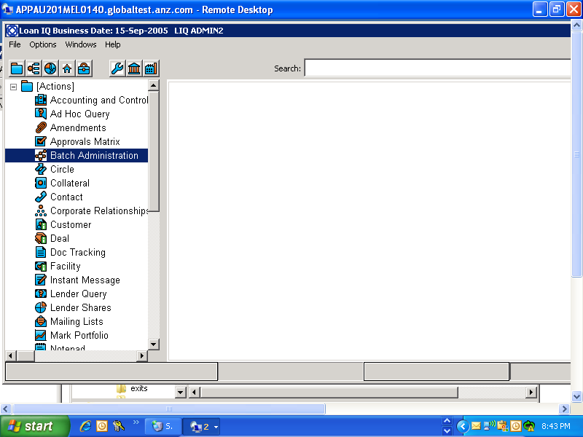

Screen:
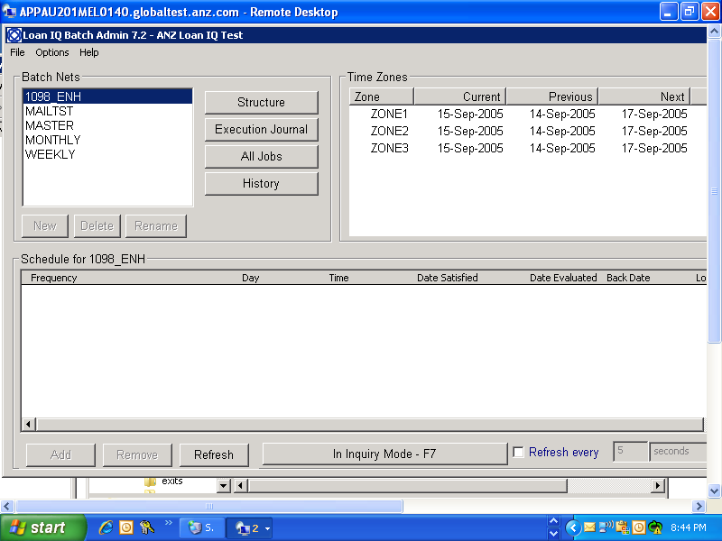

Screen3: Press F7
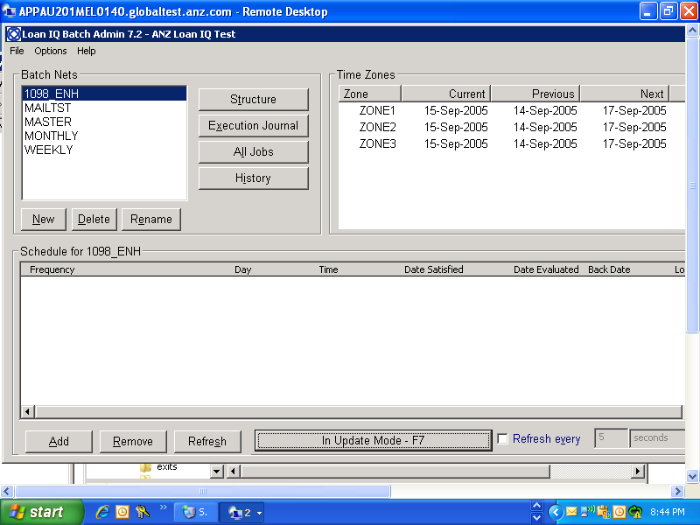

Screen:
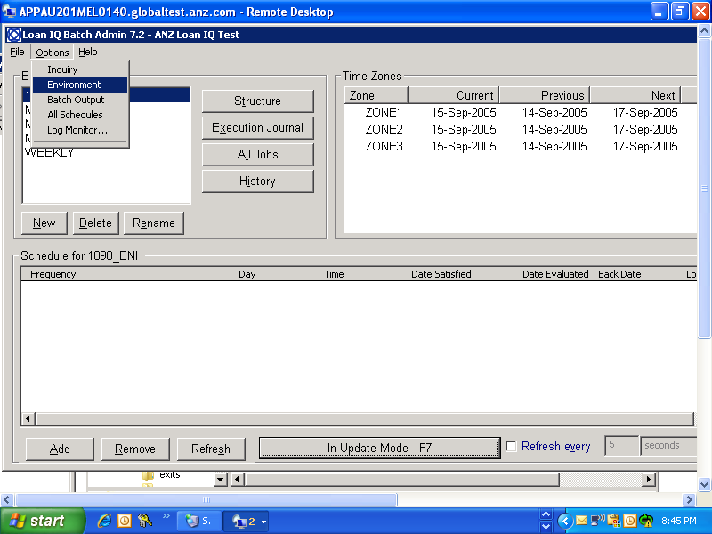

Screen:Click on environment in the above screen.
